Temasek Polytechnic

School of Informatics and IT

**Diploma in Information Technology (IT)**

Software Requirement Specifications (SRS)

**Project Particulars**

|  |  |
| --- | --- |
| **Tutor** | Qi Yutao |
| **Class** | P04 |
| **Project Title** | Hotel Management System |

**Project Team’s Particulars**

|  |  |
| --- | --- |
| **Matric Number** | **Student Name** |
| 1702378I | **Lee Jing** |
| 1705978C | **Koh Jia Hui** |
| 1705766B | **Lee Choon Loong** |
| 1603305B | **Toh Chien Yuan** |

Revision History

|  |  |  |  |
| --- | --- | --- | --- |
| **Date** | **Version** | **Description** | **Author** |
| 18/12/2018 | 1.0 | Added system functions | Lee Jing |
| 22/12/2018 | 1.1 | Added User Characteristics | Koh Jia Hui |
| 2/1/2019 | 1.2 | Added Functional Requirements | Lee Jing |
| 4/1/2019 | 1.3 | Added Data Requirements | Koh Jia Hui |
| 5/1/2019 | 1.4 | Added General Constraints and Assumptions | Toh Chien Yuan |
| 6/1/2019 | 1.5 | Added User Interface Requirements | Lee Choon Loong |

**Table of Contents**

1. DISTRIBUTION OF WORKLOAD 4

2.2. User Characteristics 5

2.3. General Constraints 5

2.4. Functional Requirements 5

2.5. Data Requirements 7

2.6. User Interface Requirements 12

2.7. Assumptions 25

3. REFERENCES 26

# DISTRIBUTION OF WORKLOAD

|  |  |
| --- | --- |
| **Requirement Gathering** | **Members** |
| System Functions | Lee Jing |
| User Characteristics | Koh Jia Hui |
| General Constraints | Toh Chien Yuan |
| Functional Requirement | Lee Jing |
| Data Requirements | Koh Jia Hui |
| User Interface Requirements | Lee Choon Loong |
| Assumptions | Toh Chien Yuan |

1. **OVERVIEW OF REQUIREMENTS**
   1. **System Functions**

There will be 4 modules in the system. They are room availability and booking module, housekeeping and staff management module, reporting module and user access control.

**Room availability and booking module -** this module enables the administrators and reception staff to look at the number of current and past reservation and create new reservation or edit reservation details. This module also allows the reception staff to check the number of available rooms in the hotel and generate payment invoice for the guest. This module also contains features such as check-in and check-out which allow reception staff to check-in and check-out guest. The reception staff will also be able to edit the guest records. Both administrators and management staff have full access to this module and its functions.

**Housekeeping and staff management module -** this module keep records of all current employees and allows the management staff to look at staff records and assign housekeeping staff maintenance duties to do. This module will also keep records of all duties and allow the management staff to add, edit and delete duties. The administrators have full access to this module and its functions.

**Reporting module -** this module generates 5 types of reports. They are mainly, report on room status, report that list all guest in a room, report that list all guest in all the rooms on a single day, room occupancy report and housekeeping report. The room occupancy and housekeeping report should be able to generate daily, weekly, monthly and yearly report which must only be accessible to the management and administrative user. The module will also include a function that allow users to preview the report before printing them.

**User access control -** this module allows the administrator to manage employees account. It includes adding new users, updating and delete user details.

# User Characteristics

The reception staff able to access to selected report in reporting module, full access room availability and booking module.

Management staff able to access to room availability and booking module, housekeeping and staff management module, reporting module and user access control.

Administrators are able to access to room availability and booking module, housekeeping and staff management module, reporting module and user access control, user account and login creation module, this module allow admin to create new staff user and new user for the new employee.

# General Constraints

Specifications of PC the hotel uses:

|  |  |
| --- | --- |
| **Operating System** | Windows XP Support Package 2 |
| **Internet Connection** | Broadband Connection |
| **Hard Disk Space** | 160GB |
| **Ram** | 1GB |

* Might face budget constraints for additional features
* Might face time constraints

# Functional Requirements

Room availability and booking module

The 3 main functions are management of guest records and reservation details, generate payment invoice and management of room availability.

**Management of guest records and reservation details -** the system shall allow the guest records to be search by Name, Phone Number and Email. The system shall also allow reservations to be search by check-in and check-out date, room number. The system shall allow users to create new, edit and delete guest record. The system shall allow users to create new, edit and delete reservations.

**Generate payment invoice -** the system should be able to calculate the number of nights the guest stayed and the total cost of the stay inclusive of additional cost. The system should generate payment invoice after calculation. The system shall allow payment invoice to be search by payment ID, date of issue and customer ID.

**Management of room availability -** the system shall allow the rooms to be search by room number, room type and room status. The system shall allow administrator and management staff to add additional rooms, edit room details and delete rooms.

Housekeeping and staff management module

The 3 main functions are searching for employee records, assigning duties to employees and management of duties.

**Searching for employee records -** the system shall allow the employees records to be search by name, phone number, email and position

**Assigning duties to employees -** the system shall allow the administrators and management staff to assign duties to the housekeeping staff by selecting duty type and inputting room ID, schedule for duty and additional remarks.

**Management of duties -** the system shall allow the duties to be search by duty type, schedule, status, staff ID and room ID. The system should allow administrator and management staff to create new, edit and delete duties. The system shall allow housekeeping employees to edit the housekeeping status.

Reporting module

The main function of this module is to generate report and allow the users to preview the report before sending it to the printer. There are 5 kinds of report to be generated.

**Room status report -** the system should generate a report which list all rooms in the hotel and their respective status.

**Report that list all guest in the room -** the system shall allow the booking records to be search by room number. The system shall retrieve the number of guest data from selected room and generate the report.

**Report that list all guest in all rooms a single day -** the system shall allow the booking records to be search by check-in and check-out date. The system shall retrieve the room number and number of guest data for those room for the selected day and generate the report.

**Room occupancy report -** the system shall retrieve all rooms data and their respective status and generate the report. The system should automatic generate this report on a daily, weekly, monthly and yearly basis.

**Housekeeping report -** the system shall retrieve all housekeeping data and duties that staff be allocated to and generate the report. The system should generate the report on a daily, weekly and monthly basis.

User access control

The main function of this module is to manage employees account and their details. The system shall allow the employees records to be search by name, phone number, email and position. The system shall allow administrators to add new users, edit user details and delete users.

# Data Requirements

# Table Name: Booking Table.

# Description: This table contain of booking detail.

|  |  |  |
| --- | --- | --- |
| **Field Name** | **Description** | **Example** |
| booking_id | ID of booking | QO1440508810 |
| customerID | ID of customer | 1 |
| datetimeBooking | Date and time when create reservation | 25/02/2019, 12:20AM |
| num_adult | Number of Adult | 2 |
| num_children | Number of Children | 0 |
| status | Booking status | Confirmed |
| paymentID | ID of payment | 1 |
| roomNum | Room number that is assign to the guest | R21 |
| checkinDateTime | Check in date & time | 14/02/2019 , 9:00AM |
| checkoutDateTime | Check out date & time | 25/02/2019 , 12:00PM |
| add_remarks | Additional remarks | King size bed |
| lateCheckout | Indication of late checkout | 1 |

# 

# 

# Table Name: Staff.

# Description: This table contain of Staff detail.

|  |  |  |
| --- | --- | --- |
| **Field Name** | **Description** | **Example** |
| staff_id | ID of staff | 1 |
| name | Staff’s name | May Cheong |
| phone_num | Staff’s phone number | +6594562587 |
| email | Staff’s email | MayC@hotmail.com |
| address | Staff’s address | 91 Paya Lebar Way, Singapore 370091 |
| position | Staff’s position in the company | Manager |
| dateJoin | Date when the staff joined the company | 25/1/2017 |
| bankAccount | Staff’s bank account number | 501-12395-6001 |
| username | Staff’s username for login in authentication | MayCH |
| password | Staff’s password for login in authentication | 1233 |

# 

# 

# Table Name: Room table.

# Description: This table contain of Room detail.

|  |  |  |
| --- | --- | --- |
| **Field Name** | **Description** | **Example** |
| room_id | ID of room | 1 |
| room_num | Room’s number | 201 |
| room_type | Room type | Suite |
| room_status | Whether the room’s available or not | Not available |
| room_price | Suite | $300 |

# 

# Table Name: Customer table.

# Description: This table contain of Customer detail.

|  |  |  |
| --- | --- | --- |
| **Field Name** | **Description** | **Example** |
| customer_id | ID of customer | 1 |
| title | Title | Mr. |
| firstName | Customer’s First Name | Choon Loong |
| lastName | Customer’s Last Name | Lee |
| NRIC | Customer’s NRIC number | S9645823B |
| Passport | Customer’s Passport number | K0000000B |
| Nationality | Customer’s nationality | Singaporen |
| phone_num | Customer’s phone number | +6596542548 |
| email | Customer’s email address | Coolloongloong@hotmail.com |
| address | Customer’s address | 684 Race Course Road, #13-102, singapore 210684 |
| credit_num | User’s credit number | 4111111111111111 |
| creditName | User’s name | Lee Choon Loong |
| creditExp | User’s credit card’s expiry date | 04/22 |

# Table Name: Housekeeping table.

# Description: This table contain of Housekeeping detail.

|  |  |  |
| --- | --- | --- |
| **Field Name** | **Description** | **Example** |
| housekeeping_id | ID of Housekeeping | 1 |
| staff_Id | Staff’s ID | 1 |
| status | Room’s status | Done |
| room_Id | Room’s ID | 23 |
| duty_type | Type of duty | Room |
| schedule | Time for stuff to do the duty | 23/12/2018 1:00pm |
| remarks | Additional remarks | Extra bed. |

# 

# Table Name: Payment table.

# Description: This table contain of Payment detail.

|  |  |  |
| --- | --- | --- |
| **Field Name** | **Description** | **Example** |
| payment_id | ID of Payment | 144050800 |
| totalCost | Total cost | $500 |
| num_night | Number of night | 3 |
| paymentType | Cash or credit card | Cash |
| additionalCost | Additional cost. | $100 |
| booking_ID | Booking ID | 1 |
| customer_ID | Customer ID | 1 |
| dateIssue | Date when invoice is generated | 23/05/2016 |
| date | Date of payment | 23/05/2016 |

# 

# User Interface Requirements

Assuming that Delonix Regia Hotel only have Single Bedroom with King size bed currently. The maximum number of guest allowed is 2 adults and 1 children (less than 12 years old). All bookings are only available for Single Bedroom.

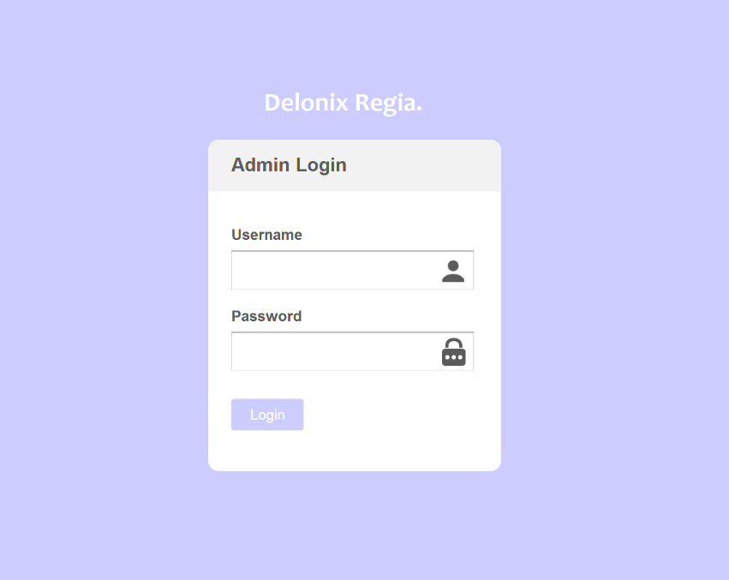

1. **Admin panel login page**

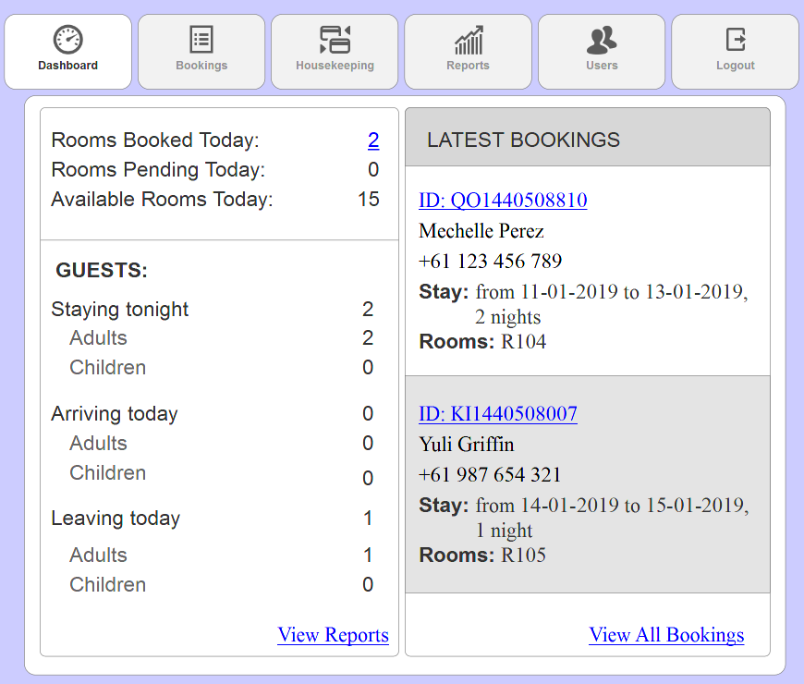

**2. Homepage (Dashboard)**

* Words with **blue underline** are link that will be redirected to another webpage
* Clicking the number of ‘Rooms Booked Today’, ‘ID’ of latest booking and ‘View All Bookings’ will redirect user to ‘Bookings page’
* Click ‘View Reports’ will redirect users to ‘Reports page’

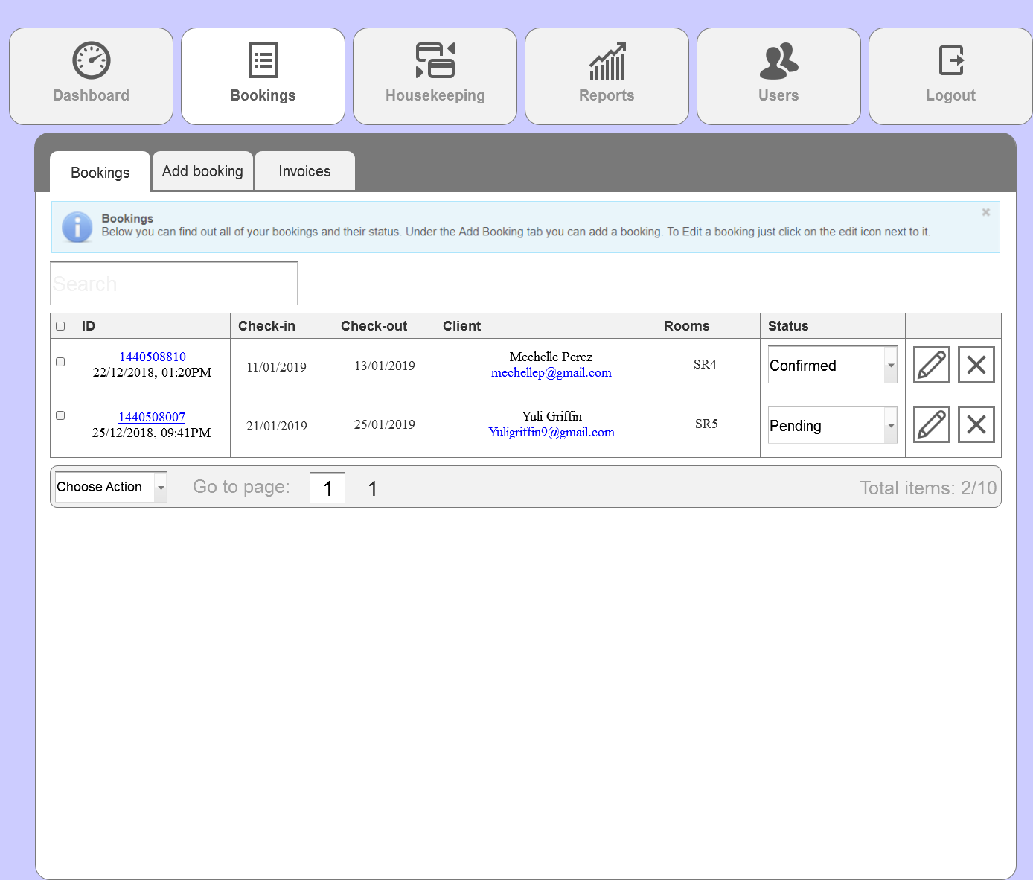

**3. Booking page**

* Client status depend on whether they have make deposit payment
* Status with confirmed represent that user had made deposit payment while status with pending represent that user have not make deposit payment
* Admin or receptionist can tick the checkbox of client to ‘Choose Action’ from the bottom navigation to ‘Delete selected’ or ‘Export’ (refer to 3i.)
* A warning message will be prompted if user did not tick any checkbox and click ‘Delete selected’ (refer to 3ii.)
* A warning message will be prompted upon clicking ‘Delete selected’ (refer to 3iii.)

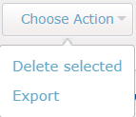

**3i. Choose Action**

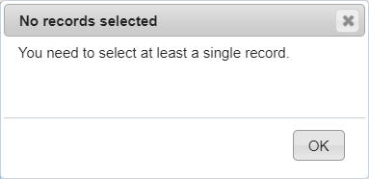

**3ii. Warning message**

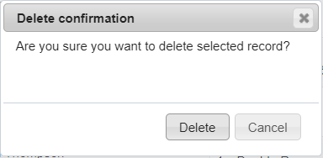

**3iii. Warning message**

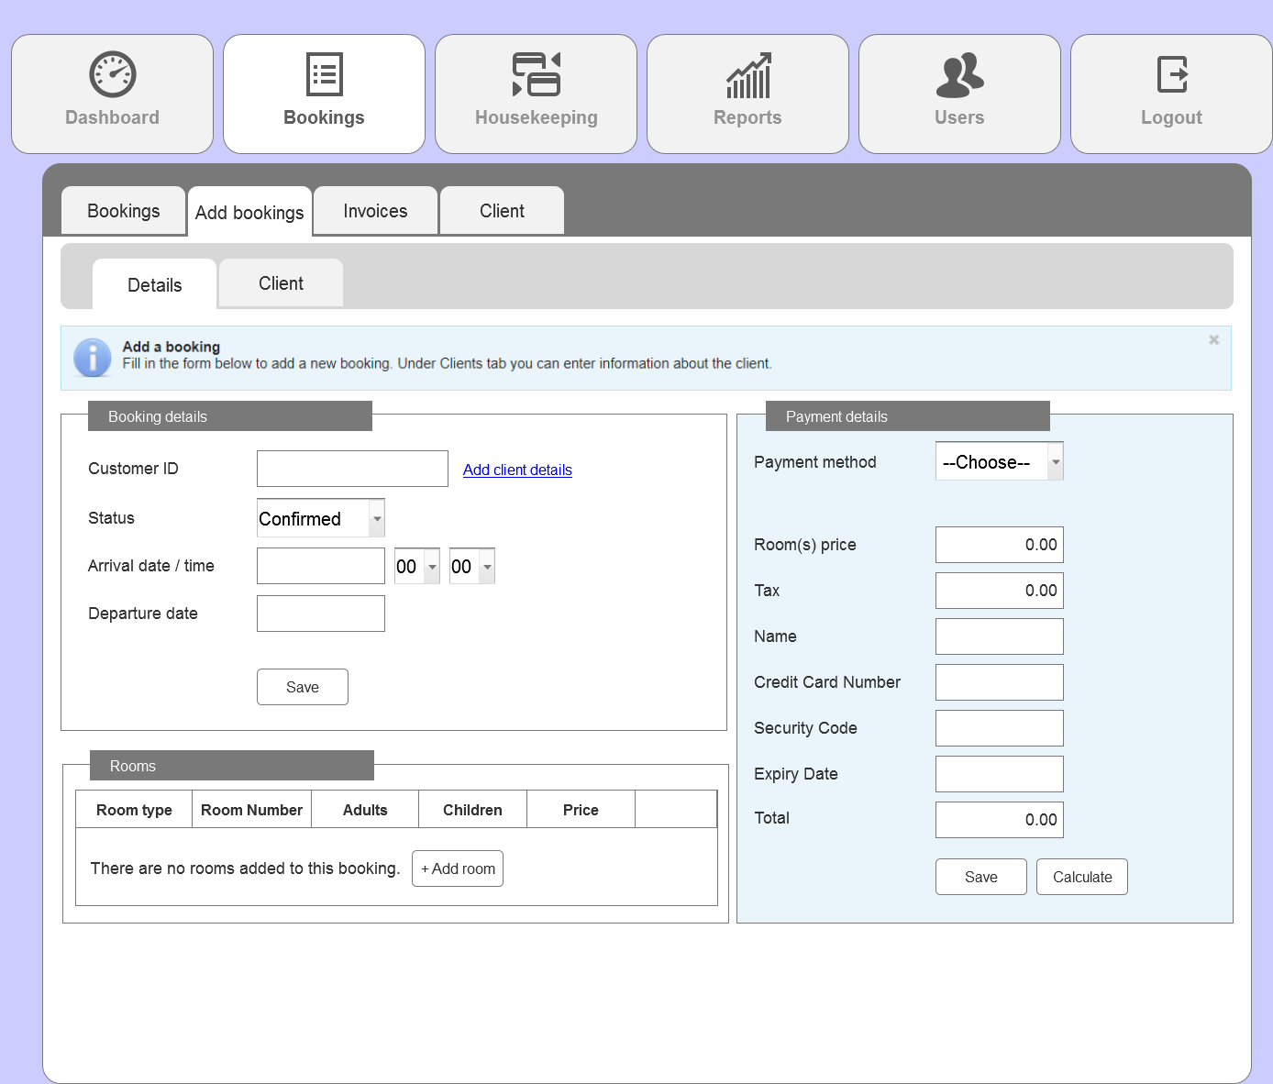

**3.1 Add bookings**

* This page can also be accessed by the receptionist if client choose to make walk-in reservations
* Clicking ‘Add client details’ will redirect user to the ‘client’ tab to let user fill in the particulars of client (annex 3.2)
* If user click on ‘Save’ button but does not have form filled up/ empty text field, user will be prompt with warning (refer to 3.1i)

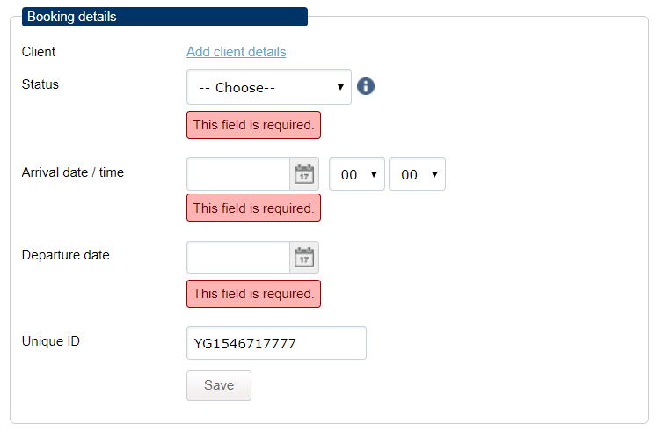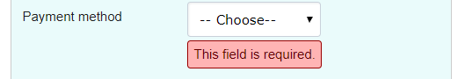

**3.1i. Required field warnings**

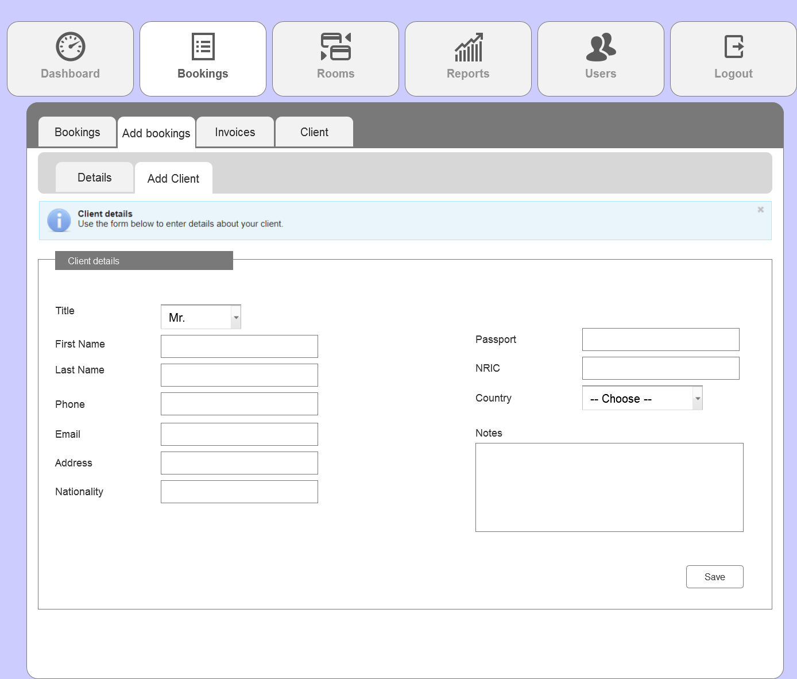

**3.2. Add client page**

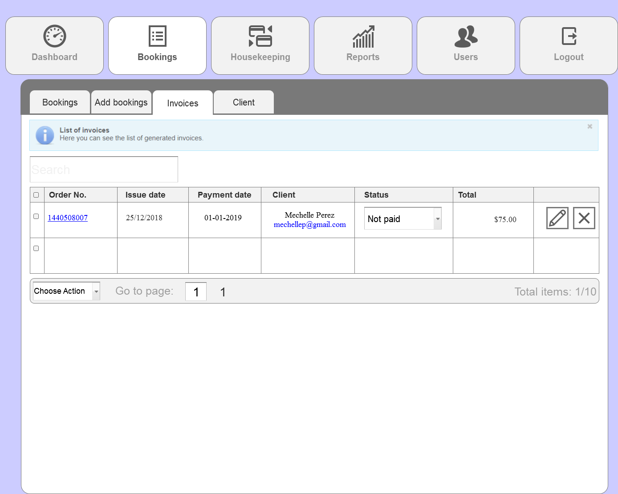

**4. Invoices**

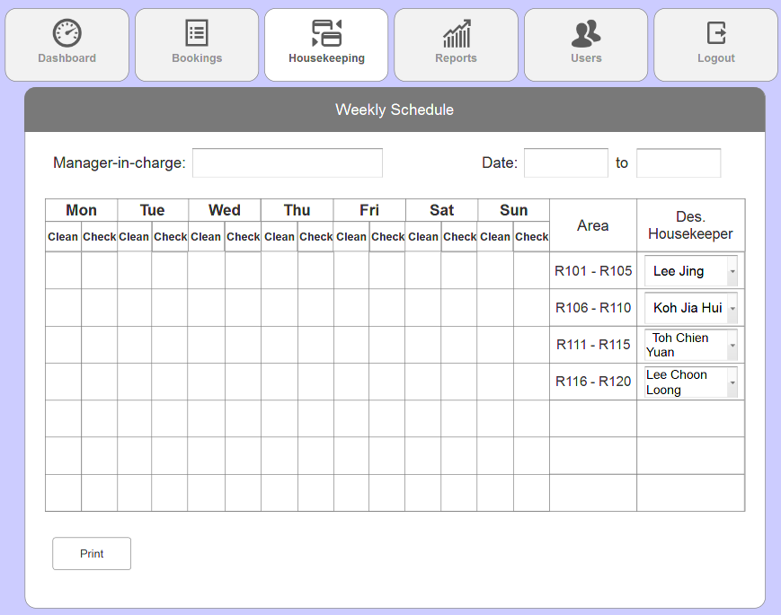

**5. Housekeeping schedule**

* Admin or the management staff will be the one allocating the designated housekeeper then print it out to let staff fill in accordingly.
* The designated housekeeper drop down list will look like (refer to 5i.)

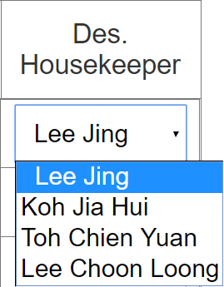

**5i. Designated housekeeper dropdown list**

* This drop down list will contain the names of all existing employees in the company (assuming that there’s 4 currently)

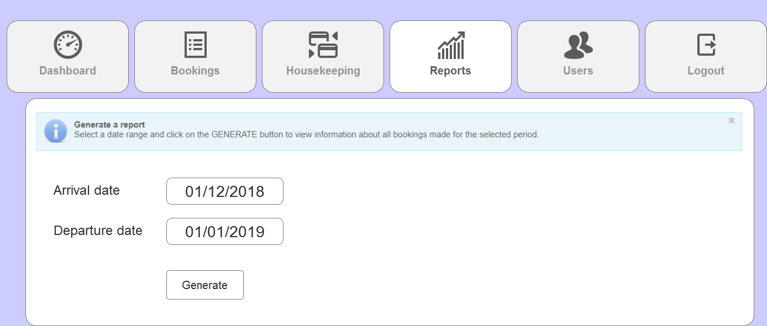

**6. Reports**

* User are to choose a date from the calendar field (refer to 6i.) to be able to generate a report
* After choosing and clicked on ‘Generate’ button, user will be shown a list of reports of the bookings and will be able to print (refer to 6.1.)

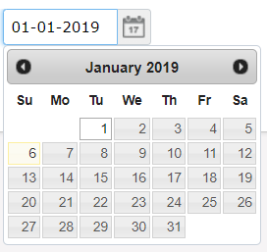

**6i. Calendar field**

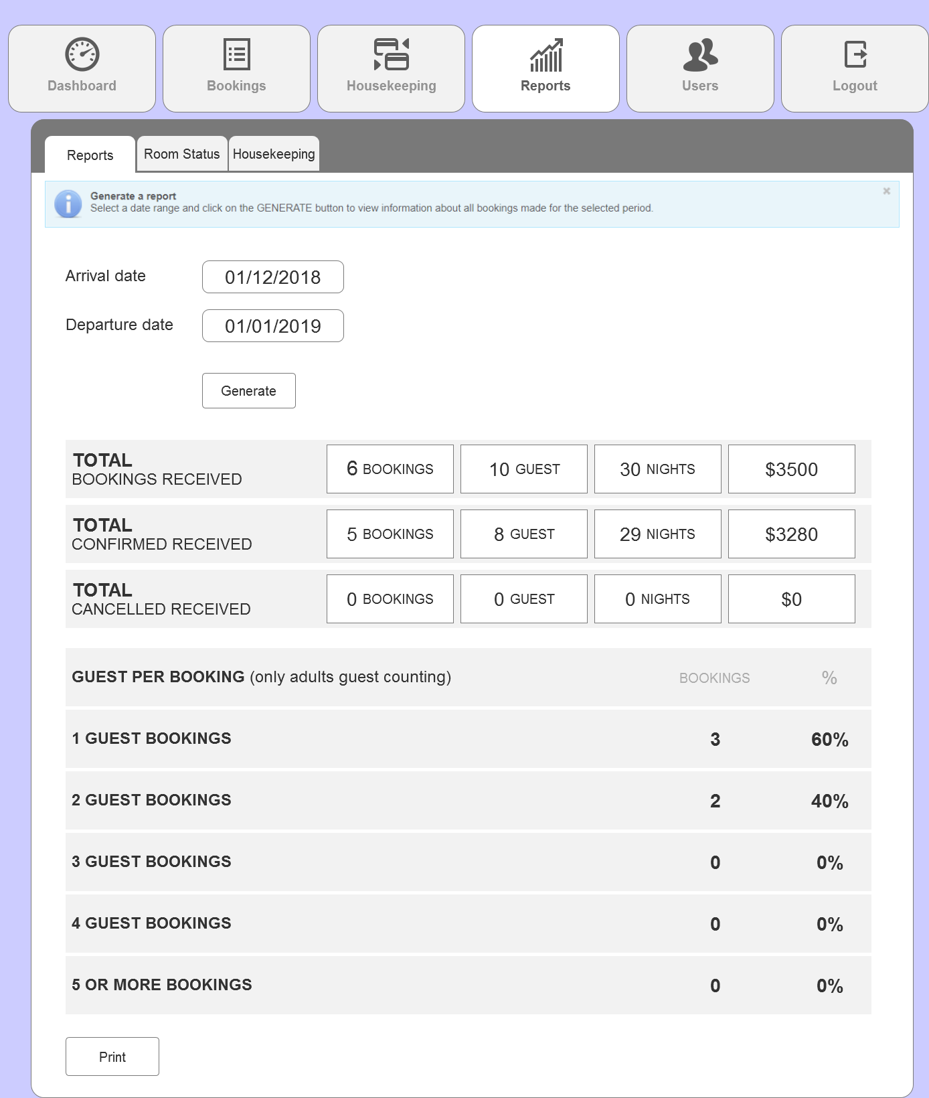

**6.1. Reports (cont.)**

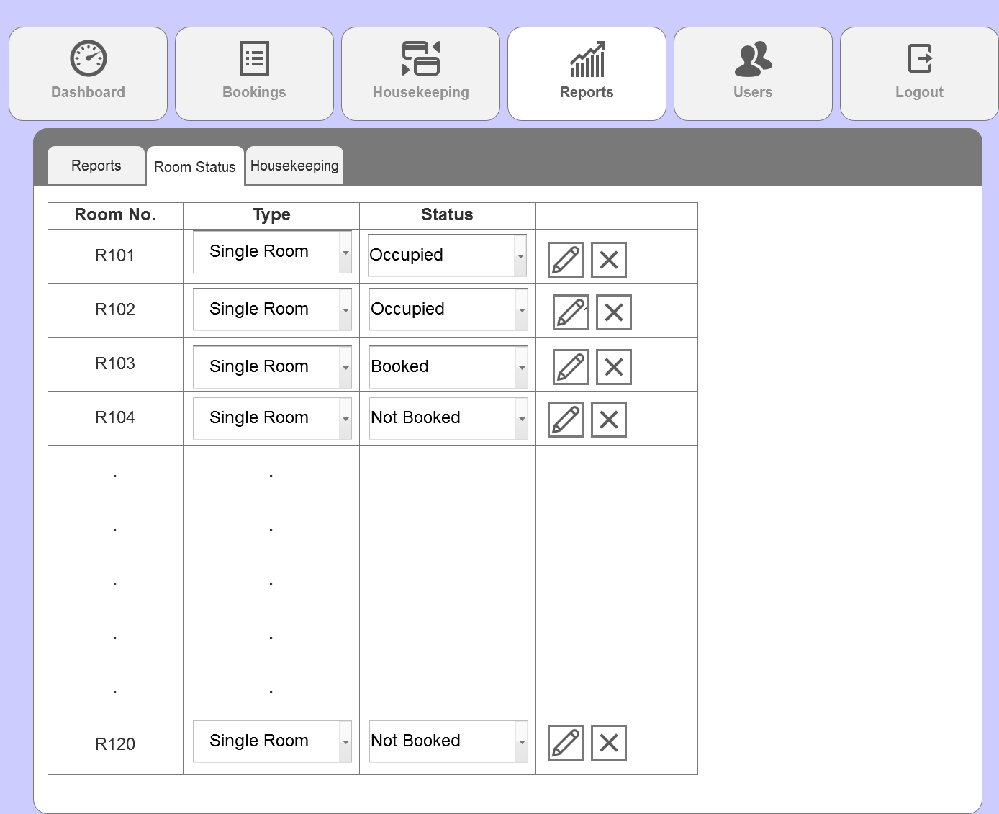

**6.2. Reports (Room Status)**

* Room status page will display **all** rooms with their status either Occupied, Booked of Not Booked.
* Users can edit the type of room (currently only Single Room available)and guest from the drop down list, and the status of the room by clicking on the edit icon.

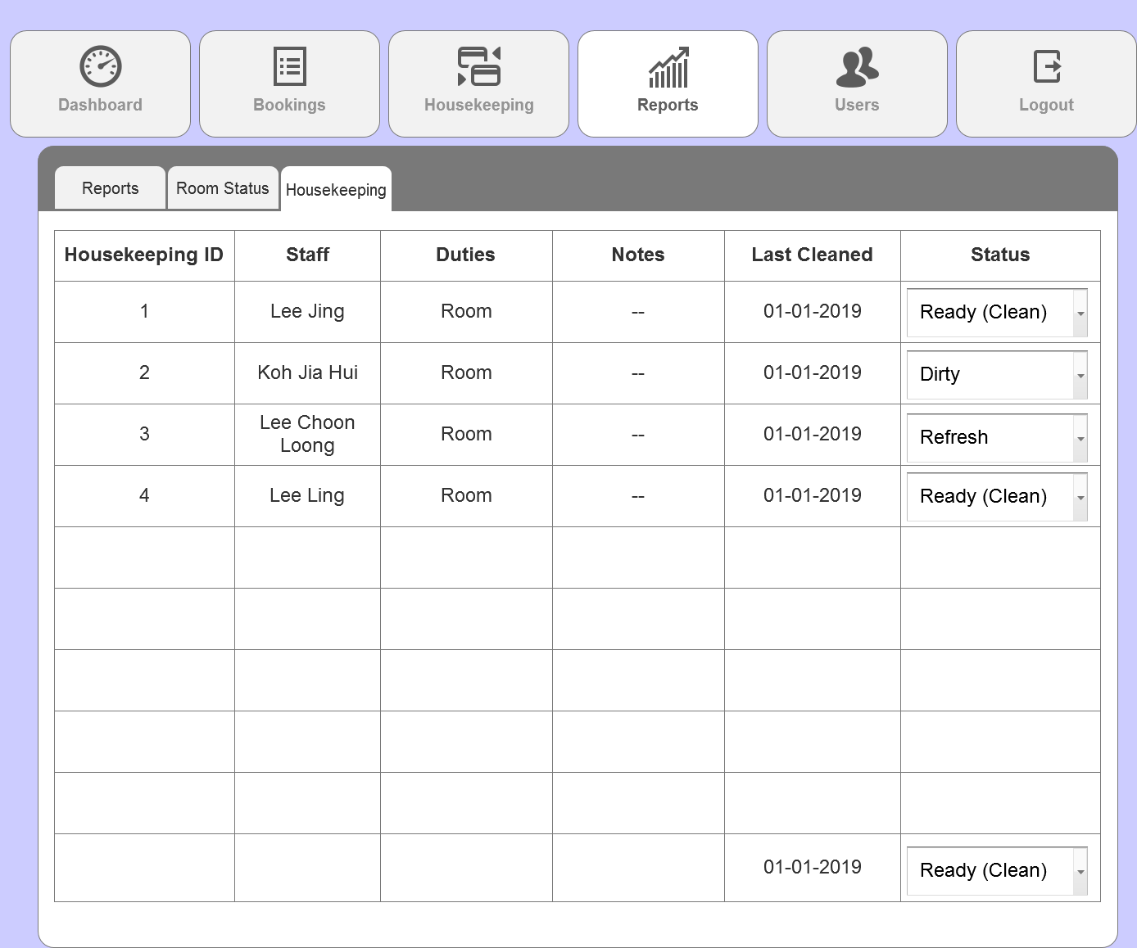

**6.3. Reports (Housekeeping)**

* User can edit the status of housekeeping from the drop down list to either Ready (Clean), Dirty or Refresh.

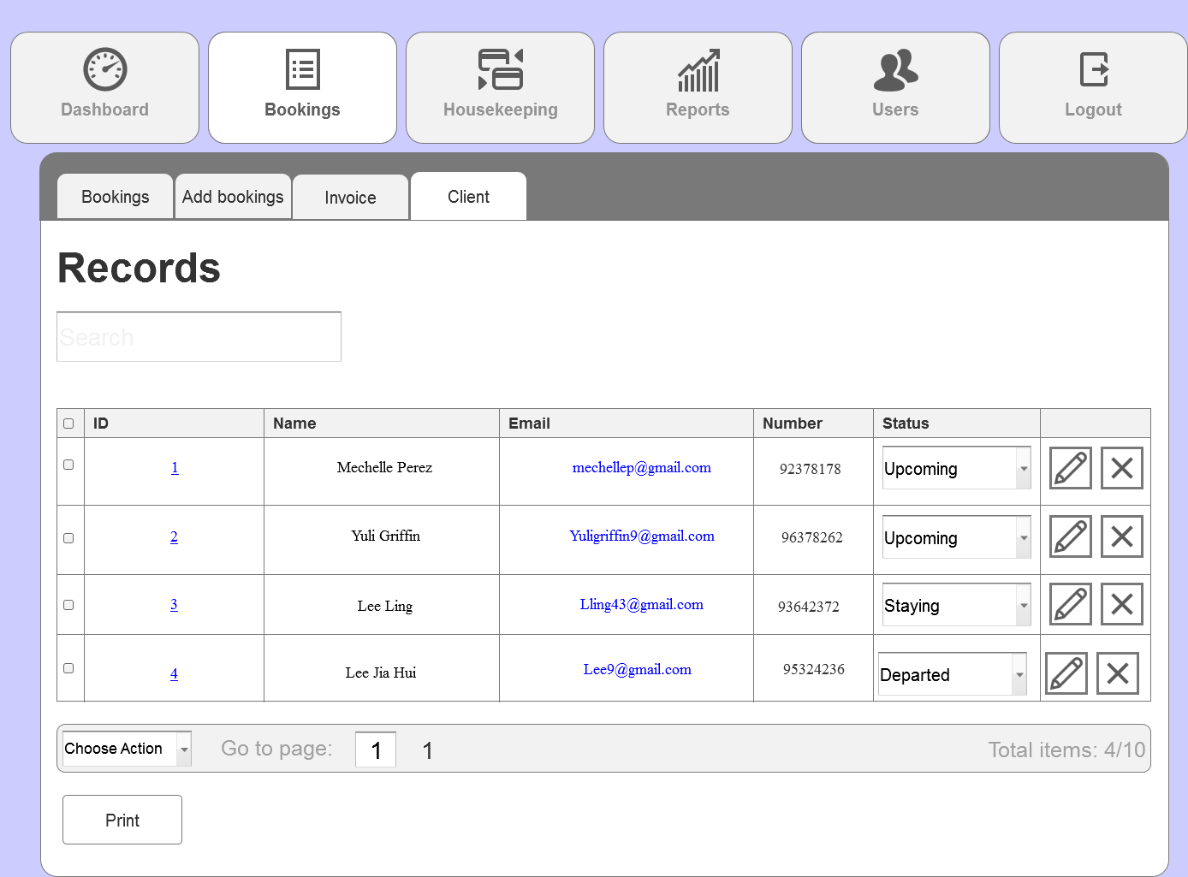

**7. Bookings (Client)**

* This page shows all records of client that made reservations.

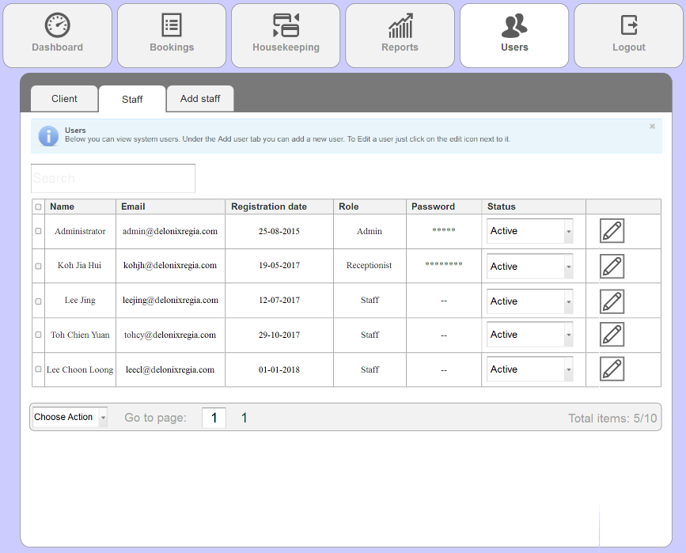

**7.1. Users (Staff)**

* This page shows all records of the current employees in the company
* Only admin and receptionist have password as they will be accessing the admin panel.

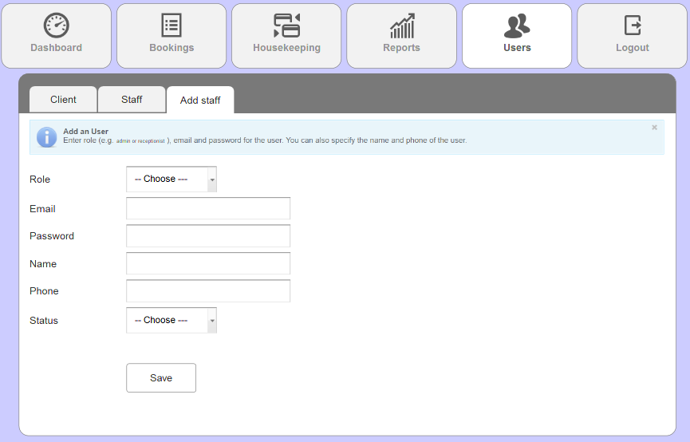

**7.2 Users (Add staff)**

User will be redirected back to the admin panel login page upon clicking the logout tab.

# Assumptions

Hardware Resources

We will purchase our servers from e-commerce websites. We will be expecting shipping to arrive in 2 weeks (12-14 days).

However, if the shipping arrives later than 14 days, it might affect our schedule and we might have to push the project back a little. Hence, the project finish date might be affected.

To mitigate such problem, we will plan out a risk management plan to reschedule or work patterns to maintain that everything will be done by the proposed date or earlier.

Software Resources

Visual Studio, Axure and MongoDB are available online. They will be downloaded into the computers on the first week and we will start working on the project itself.

# REFERENCES